**Internship Report**

**Artificial Intelligence and Machine Learning**

**on**

**“Plant disease detection and classification using CNN”**

**DLithe Consultancy Services Pvt. Ltd.**



**Internship Report**

**Trainee/Intern Name:** NIRMITHA HJ

**Reg. no:** 4SH22MC040

**Period:** 6 weeks

**Job Assignment:**

**Organization:** DLithe Consultancy Services Pvt. Ltd.

**Supervisor’s Name:** Bhavana A S

**Observations:**

**Submitted to**

Signature of Training Supervisor Signature of Co-ordinator

Date: Date:

**Letter of Transmittal**

To,

Program Co-ordinator

DLithe Consultancy services

Bengaluru

Dear Sir,

I am writing to submit my report on AIML Internship that I recently completed on Artificial Intelligence (AI) and Machine Learning (ML). The training program was an invaluable learning experience, and I am grateful for the opportunity to participate.

The training program covered various aspects of AI and ML, including basic concepts, algorithms, programming languages, and practical applications. I gained a comprehensive understanding of the role of AI and ML in modern technology and industry, and also gained hands-on experience with AI and ML tools and platforms. The training highlighted the potential of AI and ML to revolutionize various fields, including healthcare, finance, and manufacturing.

The report includes a detailed overview of the training program, including the topics covered, the learning objectives, and the outcomes achieved. It also provides observations and insights into the potential benefits and challenges of implementing AI and ML solutions in different fields.

I believe that the knowledge and skills that I acquired during the training program will be valuable to our organization. AI and ML are rapidly becoming more ubiquitous in various industries, and the ability to work with AI and ML tools and platforms will be increasingly important for our organization's success.

I hope that the report provides useful insights into the benefits of on-job training and the potential of AI and ML.

Sincerely,

Name: NIRMITHA HJ

Reg. no:4SH22MC040

**Table of Contents**

Introduction………………………………………………………………………………………………………5

Background…………………………………………………………………………………………………….…6

Project Overview…………………………………………………………………………………………….6

Problem statement………………………………………………………………………………..……….6

Solution………………………………………………………………………………………………………………7

Methodology……………………………………………………………………………………………………..9

System requirements………………………………………………………………………………………13

Hardware requirement…………………………………………………………………………………..13

Software requirement…………………………………………………………………………………….13

Schematics and Code……………………………………………………………………………………14

Results………………………………………………………………………………………………………………..21

Applications……………………………………………………………………………………………………..22

Literature survey……………………………………………………………………………………………..23

Training Experience………………………………………………………………………………………..24

Key Learnings…………………………………………………………………………………………………..25

Challenges………………………………………………………………………………………………………..26

Conclusion……………………………………………………………………………………………………..…27

**Introduction**

Artificial Intelligence and Machine Learning are two of the most popular and rapidly growing fields in computer science. They are transforming the way we live, work, and interact with technology. The purpose of this report is to provide an overview of my Internship Training experience on Artificial Intelligence and Machine Learning, and to describe the various concepts and techniques that I learned during the training.

Agriculture plays a pivotal role in sustaining global food security, making the health of crops a critical concern. Plant diseases can have significant economic and environmental impacts, affecting crop yield and quality. Early and accurate detection of these diseases is essential for timely intervention and effective crop management. In recent years, advancements in artificial intelligence, particularly Convolutional Neural Networks (CNNs), have shown great promise in revolutionizing the field of plant disease detection and classification.

Plant diseases are considered one of the main factors inﬂuencing food production, being responsible for the signiﬁcant reduction of the physical or economic productivity of the crops and, in some instances, may be an impediment to this activity. According to minimize production losses and maintain crop sustainability, it is essential that disease management and control measures be carried out appropriately, highlighting the constant monitoring of the crop, combined with the rapid and accurate diagnosis of the diseases. These practices are the most recommended by phytopathologists .The major challenge for agriculture is the correct identiﬁcation of the symptoms of major diseases that affect crops.

Manual and mechanized practices in traditional planting processes are not able to cover large areas of plantation and provide essential early information to decision-making processes, according to this, it is necessary to develop automated solutions, practical, reliable, and economically able to monitor the health of plants providing meaningful information to the decision-making process, for example, the application and correct dosage of pesticides in speciﬁc treatment certain diseases .These systems use Convolutional Neural Networks (CNNs) and their results in some experiments are already superior to humans in large-scale reconnaissance tasks. By leveraging the power of deep learning, this technology has the potential to revolutionize crop management, reduce losses, and contribute to the sustainable and efficient production of food worldwide.

**Background**

Agriculture is the backbone of global food production, sustaining the growing world population. However, plant diseases pose a significant threat to crop yield, quality, and overall agricultural sustainability. Timely and accurate identification of these diseases is crucial for effective disease management and crop protection. Traditional methods of disease detection are often manual, time-consuming, and may lack scalability. Therefore, there is a pressing need for automated and efficient solutions that leverage advanced technologies like Convolutional Neural Networks (CNNs) to detect and classify plant diseases accurately.

**Project overview**

Plants and crops that are infected by pests have an impact on the country's agricultural production. Usually, farmers or professionals keep a close eye on the plants in order to discover and identify diseases. However, this procedure is frequently time-consuming, costly, and imprecise. Plant disease detection can be done by looking for a spot on the diseased plant's leaves. The goal of this paper is to create a Disease Recognition Model that is supported by leaf image classification.

To detect plant diseases, we are utilizing image processing with a Convolution neural network (CNN). A convolutional neural network (CNN) is a form of artificial neural network that is specifically intended to process pixel input and is used in image recognition.

**Problem statement**

The automated solutions for the identiﬁcation of plant diseases using images and machine learning, especially CNN, has provided signiﬁcant advances to maximize the accuracy of correct diagnosis. Convolutional Neural Networks is a subset of machine learning approaches that have emerged as a versatile tool for assimilating large amounts of heterogeneous data and providing reliable predictions of complex and uncertain phenomena.

Computer Vision, along with Artiﬁcial Intelligence (AI), has been developing techniques and methods for recognizing and classifying objects with signiﬁcant advances . These systems use Convolutional Neural Networks (CNNs) and their results in some experiments are already superior to humans in large-scale reconnaissance tasks. By leveraging the power of deep learning, this technology has the potential to revolutionize crop management, reduce losses, and contribute to the sustainable and efficient production of food worldwide.

**Solution**

To implement a solution for plant disease detection and classification using Convolutional Neural Networks (CNNs), you can follow these steps:

### 1. Data Collection and Preprocessing:

**Dataset Collection:** Gather a diverse dataset containing images of healthy plants and plants affected by various diseases. You can use publicly available datasets or create your own.

**Data Preprocessing:**

* + Resize all images to a consistent size.
  + Normalize pixel values to a scale of 0 to 1.
  + Apply data augmentation techniques (e.g., rotation, flipping, zooming) to increase the diversity of the dataset.

### 2. Model Architecture:

Choose or Design a CNN Architecture:

* + You can use pre-trained models like VGG16, ResNet, or MobileNet and fine-tune them for your specific task.
  + Alternatively, design a custom CNN architecture based on the complexity of your dataset and computing resources.

Add Layers:

* + Include convolutional layers, activation functions (e.g., ReLU), pooling layers, and fully connected layers.
  + Customize the architecture based on the specific characteristics of plant diseases.

### 3. Model Compilation:

* Compile the Model:
  + Specify the loss function, optimizer, and evaluation metric.
  + For a multi-class classification task, categorical cross entropy is a common choice.

**4. Model Training:**

* Split the Dataset:
  + Divide the dataset into training, validation, and test sets.
* Train the Model:
  + Train the CNN model using the training dataset.
  + Use the validation dataset to monitor the model's performance and prevent overfitting.

### 5. Model Evaluation:

* Evaluate the Model:
  + Assess the model's performance on the test dataset.

### 6. Prediction:

* Make Predictions:
  + Use the trained model to make predictions on new images.

### 7. Fine-Tuning:

* Optimize Hyperparameters:
  + Experiment with learning rates, batch sizes, and other hyperparameters to improve model performance.
* Fine-Tune the Model:
  + Adjust the model architecture based on the model's performance on the validation set.

### 8. Deployment:

* Deploy the Model:
  + Implement the model in a real-world setting, such as a web application, mobile app, or embedded system.
* Continuous Monitoring:
  + Regularly monitor the model's performance and update it with new data to maintain accuracy.

**Methodology**

**VGG 19 Architecture:**

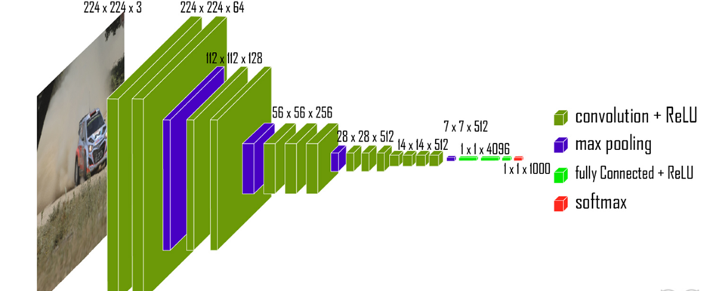

**Fig 6.1: VGG 19 Architecture**

Vgg19 is one of the convolution neural networks, which has 19 layers like convolution layer, fully connected layer, SoftMax layer, max pool layer. When an RGB image is given as an input to the network the vgg19 resizes it to (224, 224, 3). It is a fixed size. During preprocessing it subtracts the RGB mean value. With the help of the kernel the pixels in images are processed. The spatial resolution process is mandatory to identify the differences in the images by spatial padding. Soft max layer is the final layer which will have output based on the number of classes.

The vgg-19 has following layers-

1. Convolutional layer

2. Max pooling

3. Fully connected

**Convolutional layer:**

The convolutional layer is the first building element of CNN. It extracts characteristics from the input image. Convolution merges the two sets of data mathematically. Convolution can be used to transform the supplied data. Convolution is used to generate the future map.

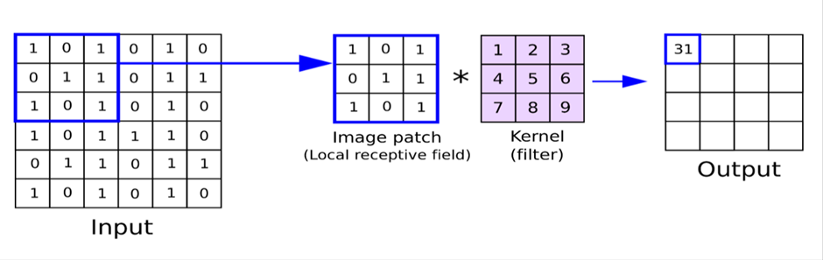

**Fig 6.2: Convolutional layer**

**Max Pooling Layer:**

Convolution layers are used to generate feature maps. The dimension of the feature maps is reduced by 50% when pooling layers are used. There are two types of pooling layers :

1. Average pooling
2. Maximum pooling.

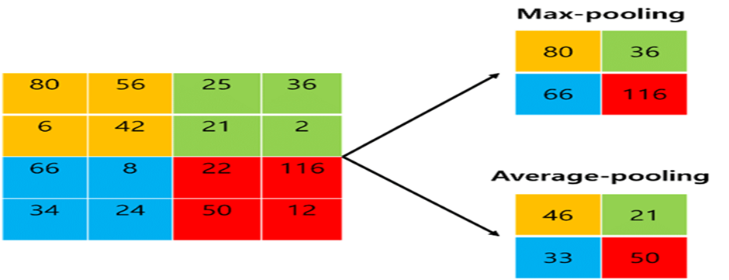

**Fig 6.3: Max Pool Layer**

**Fully connected Layer:**

The fully connected layer receives the final feature map outputs or max pooling layer matrix outputs. The fully connected layers' inputs are flattened to one column vectors. The following is an example, as illustrated in the diagram:

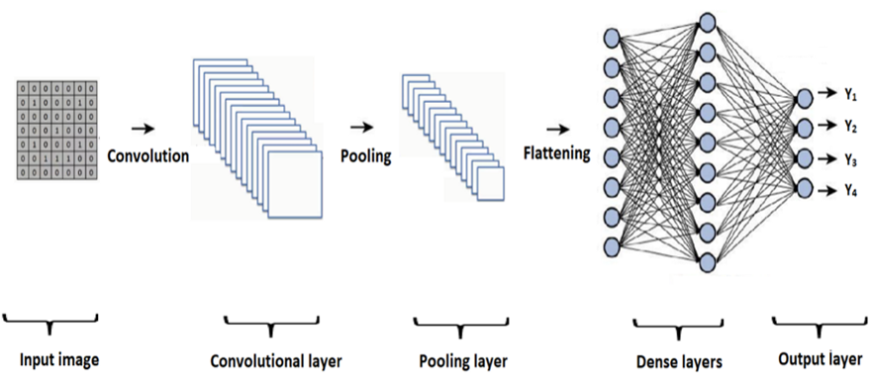

**Fig 6.4: Fully Connected Layer**

**System Architecture:**

To depict the relationship between different components, a system architecture diagram might be utilized. Typically, they are designed for systems that comprise both hardware and software, which are depicted in the Fig 6.5

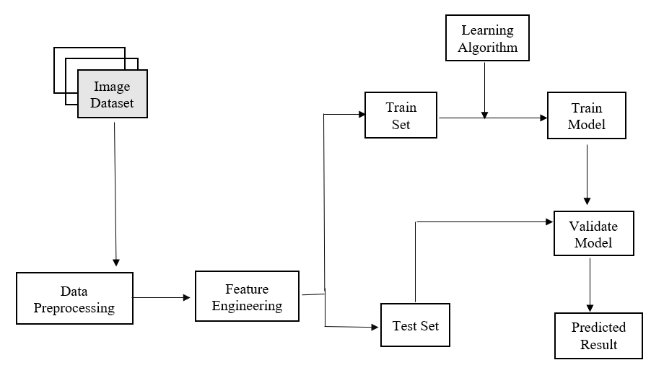

Fig 6.5: System Architecture

The Model has two parts:

**Training:**

The test dataset contains following feature extraction, the model recognizes the leaf that belongs to the appropriate classes. The following architecture is proposed to identify diseased plant leaves using machine learning classification algorithms: Testing. Initially, photos of diseased leaves of various kinds are collected for the leaf data set. The photographs are in either jpeg or png format. Images are altered during the image processing procedure. The Vgg19 convolution neural network has 19 layers, 16 of which are neural network layers, 5 of which are fully connected layers, a soft max layer, and a max pool layer. The leaf factor is calculated after the feature extraction by the CNN layers.

**Testing:**

After image pre-processing, the image dataset will be compared to the machine learning model. After feature extraction, compute the leaf factor of the test dataset. The model recognizes the leaf that belongs to the appropriate crop class. In order to identify the diseased plant leaves using machine learning classification algorithms, the following architecture is proposed:

Step 1: The data set is split into training data and testing data manually.

Step 2: The images in the data set are read and pre-processed.

Step 3: After Preprocessing, feature extraction of the plant leaves is done using VGG19, a convolutional neural network that is 19 layers deep.

Step 4: The leaf factors are calculated and the model file will be generated.

Step 5: The image to be tested is pre-processed and will be compared to the model file to identify the class or the type of diseased plant leaf

**System Requirements**

**Hardware Requirement:-**

Processor :IntelCore i3 and Above

RAM : 8.00GB

System Type : 64 bit Operating System

**Software Requirement:-**

Operating System : Windows 10 / Windows 11

Programming Language : Python

IDE: Google colab

Libraries: Pandas, numpy, matplotlib, seaborn, tensorflow.

**Schematics and Code**

import numpy as np # linear algebra

import pandas as pd # data processing, CSV file I/O (e.g. pd.read_csv)

import os

for dirname, _, filenames in os.walk('/kaggle/input'):

for filename in filenames:

break

from google.colab import drive

drive.mount('/content/drive')

import pandas as pd

import numpy as np

import matplotlib.pyplot as plt

import seaborn as sns

from sklearn.model_selection import train_test_split

from sklearn.metrics import confusion_matrix , classification_report , auc , accuracy_score

import tensorflow as tf

from tensorflow import keras

from PIL import Image

import cv2

import matplotlib.image as mpimg

import tensorflow as tf

from tensorflow import keras

from keras.layers import Dense,Dropout,Conv2D, Flatten,MaxPooling2D

from keras.models import Sequential

from tensorflow.keras.preprocessing import image_dataset_from_directory

import warnings

warnings.filterwarnings('ignore')

path = "/content/drive/MyDrive/archive (14)/Train/Train"

train = image_dataset_from_directory(path, batch_size=32,

image_size=(256,256),shuffle=True)

path = "/content/drive/MyDrive/archive (14)/Test/Test"

test = image_dataset_from_directory(path, batch_size=32,

image_size=(256,256),shuffle=True)

path = "/content/drive/MyDrive/archive (14)/Validation/Validation"

valid = image_dataset_from_directory(path, batch_size=32,

image_size=(256,256),shuffle=True)

class_labels = train.class_names

class_labels

print(len(train))

print(len(test))

print(len(valid))

#Data Preprocessing

for image_batch,image_label in train.take(1):

print(image_batch[0])

print(class_labels[image_label[0].numpy()])

#Train Image Data

plt.figure(figsize=(20,20))

for image_batch , image_label in train.take(1):

for i in range(20):

plt.subplot(5,4,i+1)

plt.imshow(image_batch[i].numpy().astype("uint8"))

plt.title(class_labels[image_label[i].numpy()])

plt.axis("off")

#Resizing and Rescaling Images

resizing_and_rescaling = tf.keras.Sequential([

tf.keras.layers.experimental.preprocessing.Resizing(256,256),

tf.keras.layers.experimental.preprocessing.Rescaling(1.0/255)

])

#Data Augmentation

data_augmentation = tf.keras.Sequential([

tf.keras.layers.experimental.preprocessing.RandomContrast(0.3),

tf.keras.layers.experimental.preprocessing.RandomFlip('horizontal_and_vertical'),

tf.keras.layers.experimental.preprocessing.RandomZoom(0.3),

tf.keras.layers.experimental.preprocessing.RandomRotation(0.2)

])

#Create CNN Model

IMAGE_SIZE=256

CHANNELS=3

BATCH_SIZE=32

EPOCHS=10

input_shape=(BATCH_SIZE , IMAGE_SIZE, IMAGE_SIZE, CHANNELS)

model= tf.keras.models.Sequential([

resizing_and_rescaling,

data_augmentation,

# Convolution layer 1

tf.keras.layers.Conv2D(filters=64, kernel_size=(3,3), strides=(1,1),padding='valid',activation='relu',input_shape=input_shape),

tf.keras.layers.MaxPool2D(pool_size=(2,2)),

# Convolution layer 2

tf.keras.layers.Conv2D(filters=64, kernel_size=(3,3),strides=(1,1),padding='valid',activation='relu'),

tf.keras.layers.MaxPool2D(pool_size=(2,2)),

# Convolution layer 3

tf.keras.layers.Conv2D(filters=64, kernel_size=(3,3),strides=(1,1),padding='valid',activation='relu'),

tf.keras.layers.MaxPool2D(pool_size=(2,2)),

# Convolution layer 4

tf.keras.layers.Conv2D(filters=64, kernel_size=(3,3),strides=(1,1),padding='valid',activation='relu'),

tf.keras.layers.MaxPool2D(pool_size=(2,2)),

# Flatten Layers

tf.keras.layers.Flatten(),

# Dense layers

tf.keras.layers.Dense(units=500,activation='relu'),

tf.keras.layers.Dropout(0.4),

tf.keras.layers.Dense(units=500,activation='relu'),

tf.keras.layers.Dropout(0.3),

tf.keras.layers.Dense(units=100,activation='relu'),

tf.keras.layers.Dropout(0.2),

tf.keras.layers.Dense(units=3,activation='softmax')

])

model.build(input_shape=input_shape)

model.summary()

model.compile(optimizer="adam",

loss="sparse_categorical_crossentropy",

metrics=["accuracy"])

history = model.fit(train , batch_size=32 ,epochs=10,

verbose=1,

validation_data=valid) # epochs=10

#Accuracy and loss on Train and Test

loss,acc = model.evaluate(train)

print("Loss on Train data:",loss)

print("Accuracy on Train data:",acc)

loss1,acc1 = model.evaluate(test)

print("Loss on Test data:",loss1)

print("Accuracy on Test data:",acc1)

acc = history.history["accuracy"]

val_acc = history.history["val_accuracy"]

loss = history.history["loss"]

val_loss = history.history["val_loss"]

EPOCHS=10

plt.figure(figsize=(12,6))

plt.subplot(1,2,1)

plt.plot(range(EPOCHS),acc, label="Training Accuracy")

plt.plot(range(EPOCHS),val_acc, label="Validation Accuracy")

plt.legend(loc="lower right")

plt.title("Training and Validation Accuracy")

#plt.figure(figsize=(6,6))

plt.subplot(1,2,2)

plt.plot(range(EPOCHS),loss, label="Training Loss")

plt.plot(range(EPOCHS),val_loss, label="Validation Loss")

plt.legend(loc="lower right")

plt.title("Training and Validation Loss")

plt.show()

#Image Predictions on Test Data

def Prediction(model,img):

img_array = tf.keras.preprocessing.image.img_to_array((images[i].numpy()))

img_array = tf.expand_dims(img_array,0) # create a batch

predictions = model.predict(img_array)

predicted_class = class_labels[np.argmax(predictions[0])]

confidence = round(100*(np.max(predictions[0])),2)

return predicted_class , confidence

plt.figure(figsize=(20,25))

for images , labels in test.take(1):

for i in range(20):

ax = plt.subplot(5,4,i+1)

plt.imshow(images[i].numpy().astype("uint8"))

#plt.title(class_labels[labels[i]])

predicted_class , confidence = Prediction(model,images[i].numpy())

actual_class = class_labels[labels[i]]

plt.title(f"Actual:{actual_class}\n Predicted:{predicted_class}\n Confidence:{confidence}%")

plt.axis("off")

**Results**

A 96.3% accuracy rate was achieved using early stopping while Training the model on 10 epochs. Figure 9.1 depicts the visualization of training and validation accuracy.

The result of detecting and recognizing a plant is shown in Figure 9.2.

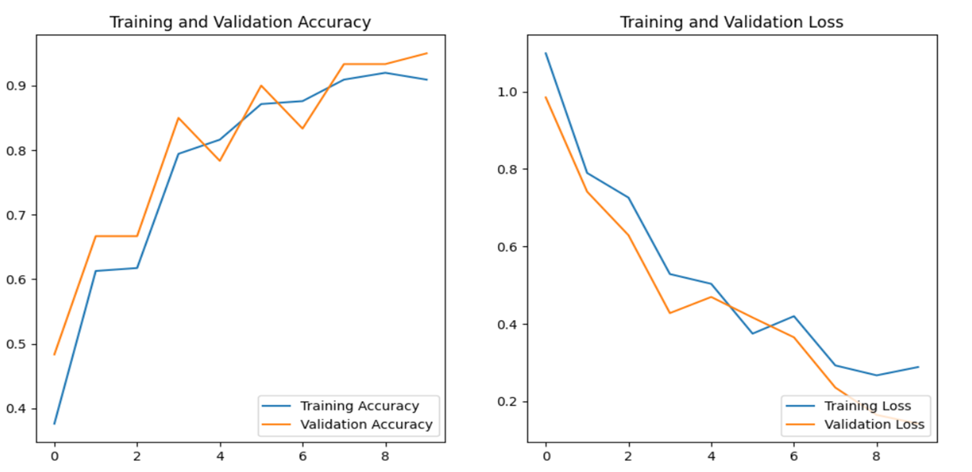

Fig 9.1: Accuracy and Loss graph after Training vs Validation

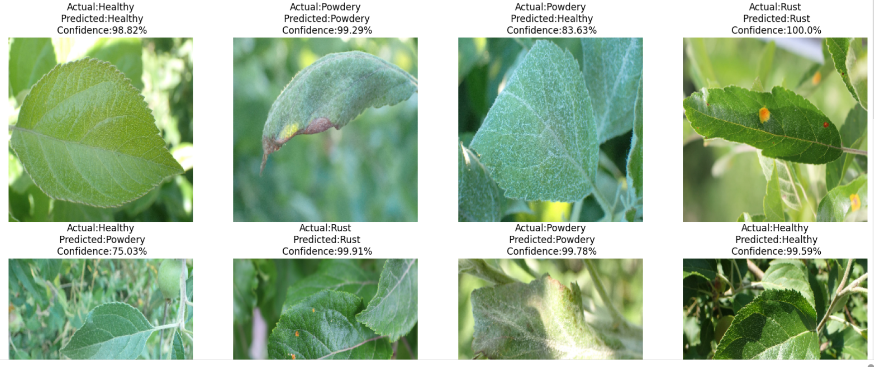Fig 9.2: Plant disease detection and classification with accuracy

**Applications**

The application of plant disease detection and classification using Convolutional Neural Networks (CNNs) has a wide range of practical uses in agriculture and plant science. Here are some key applications:

### 1. Precision Agriculture:

* Targeted Treatment: Identify and treat specific plants affected by diseases rather than applying treatments to entire fields, optimizing resource usage.
* Reduced Chemical Usage: By precisely detecting diseased plants, farmers can reduce the unnecessary application of pesticides or fungicides.

### 2. Early Disease Detection:

* Timely Intervention: Early detection allows for prompt intervention, preventing the spread of diseases and minimizing crop losses.
* Preventive Measures: Farmers can take preventive measures in response to early disease warnings, such as adjusting irrigation, enhancing soil nutrition, or implementing other management practices.

### 3. Crop Monitoring:

* Continuous Surveillance: Implement a continuous monitoring system to track the health of crops throughout the growing season.
* Dynamic Decision-Making: Make dynamic decisions based on real-time information about the prevalence and severity of diseases in the field.

### 4. Research and Disease Understanding:

* Disease Research: Aid researchers in studying plant diseases by providing a tool for large-scale data analysis and understanding disease patterns.
* Genetic Analysis: Explore correlations between genetic factors and disease susceptibility in plants.

### 5. Educational Tools:

* Training and Education: Develop educational tools for farmers, agronomists, and students to learn about different plant diseases and their symptoms.
* Capacity Building: Enhance the capacity of agricultural professionals to identify and manage plant diseases effectively.

**Literature survey**

**1.** K.Muthukannan and colleagues discovered spot infections in leaves and categorized them according to the diseased leaf categories using various machine learning algorithms. LVQ - Learning Vector Quantization, FFNN - Feed Forward Neural Network, and RBFN - Radial Basis Function Networks were utilized to diagnose diseased plant leaves by analyzing the collection of form and texture data from the afflicted leaf picture. The simulation showed that the proposed system is effective. With the support of this work, a machine learning-based system for improving crop quality in the Indian economy can be developed.

**2.** Plant disease identification and treatment using neural network models, Konstantinos P. Ferentinos and colleagues built CNN models to conduct crop disease identification and diagnosis using basic leaf pictures of healthy and sick plants. The models were trained using an open collection of 87,848 photos, which included 25 kinds of plants in 58 various classes of [plant, illness] pairs, including non-affected plants. Multiple model architectures were developed, with the topper forming one achieving a success rate of 99.53 percent.

**3.** In the study Soybeans, Crop Disease Detection Using Cnns, Serawork Wallelign, and the others The viability of CNN for crop diseases identification in leaves pictures captured in the natural surroundings is presented in this study. To accomplish the soybeans plant disease classification, the model is built using the LeNet architecture.

To diagnose plant leaf illnesses, Ashwin Dhakal and colleagues created a model that includes feature extraction, segmentation, and classification of collected leaf patterns. Yellow Leaf Curl Virus, Bacterial Spot, Late Blight, and Healthy Leaf are the four classifier labels employed. With 20 epochs, the retrieved characteristics are fitted into the neural network. Various neural network based topologies are used, with the greatest accuracy of 98.59 percent in predicting plant disease.

**4.** The convolutional neural network was used by Garima Shrestha and colleagues to identify plant disease in 2020. With an accuracy of 88.80 percent, the authors were able to classify 12 plant diseases. Experimentation was carried out by using a collection of 3000 high-resolution RGB photographs.The convolutional layer and pooling layer have 3 blocks in this network. Eventually, the network becomes very expensive as a result of this. Additionally, the model's F1 score is 0.12, which is extremely poor due to the significant amount of erroneous negative predictions.

**Training Experience**

Hands-on Learning: My training program was designed to provide hands-on experience with AI and ML tools and technologies. I was given the opportunity to work on real-world projects and problems, which helped me develop practical skills and apply theoretical concepts.

Mentorship: I was fortunate to have a mentor who was an experienced AI and ML professional. My mentor provided guidance, feedback, and support throughout my training program, which was invaluable in my learning journey.

Collaboration: One of the most exciting aspects of my training program was the opportunity to work with a team of professionals from different backgrounds. We collaborated on projects and shared ideas, which helped me develop my communication and collaboration skills.

Exposure to Industry Trends: I was able to stay up-to-date with the latest industry trends and developments in AI and ML through various workshops, seminars, and conferences. This helped me gain a broader perspective on the field and prepare for future challenges.

Use of Industry-standard Tools and Technologies: During my training, I had the opportunity to work with industry-standard tools and technologies such as Python, TensorFlow, Keras, and Scikit-Learn. This allowed me to gain practical skills that are in demand in the industry.

Importance of Data Preparation: One of the most important lessons I learned during my training was the critical role of data preparation in the success of AI and ML projects. I learned how to collect, clean, and preprocess data to make it suitable for training models.

Iterative Process: I also learned that developing an AI or ML model is an iterative process that requires a lot of experimentation and tweaking. It is essential to have a feedback loop that allows for continuous improvement of the model.

**Key Learnings**

During the training program, I learned a range of skills and concepts related to Artificial Intelligence and Machine Learning. Some of the key skills that I acquired are:

Understanding of Artificial Intelligence: I gained a comprehensive understanding of Artificial Intelligence, including the various subfields such as Machine Learning, Deep Learning, and Natural Language Processing.

Machine Learning Concepts and Algorithms: I learned about various Machine Learning concepts and algorithms, including Supervised and Unsupervised Learning, Decision Trees, Random Forests, Support Vector Machines, and K-Nearest Neighbors.

Deep Learning and Neural Networks: I gained a deep understanding of Deep Learning and Neural Networks, including Convolutional Neural Networks and Recurrent Neural Networks.

Programming Skills: I developed strong programming skills in Python, including libraries such as Numpy, Pandas, and Matplotlib.

Data Preprocessing and Analysis: I learned various techniques for data preprocessing and analysis, including Data Cleaning, Data Wrangling, and Exploratory Data Analysis.

**Challenges:**

**Variability in Disease Manifestations:** Plant diseases can exhibit diverse symptoms, and the manifestation of these symptoms can vary based on factors such as plant species, environmental conditions, and the specific pathogen involved.Developing a CNN model capable of accurately recognizing and classifying this variability is a complex challenge.

**Data Annotated for Diverse Conditions:**Obtaining a comprehensive and diverse dataset that captures the spectrum of plant diseases under various environmental conditions is challenging.The model's performance may be hindered if the training data does not adequately represent the real-world variability encountered in agricultural settings.

**Real-Time Detection in the Field:**Implementation of plant disease detection systems in real-time, on-site conditions is essential for prompt intervention. However, achieving real-time performance while maintaining accuracy poses a technical challenge.

**Generalization Across Crops:**Developing a model that can generalize well across different plant species and types of diseases is critical for creating a versatile and widely applicable solution.The challenge lies in building a model that is not overly specific to certain crops or diseases, hindering its adaptability.

**Interpretability and Explainability:**CNNs, being complex models, often lack interpretability. Understanding how the model arrives at a specific classification is crucial for gaining trust from agricultural stakeholders and facilitating informed decision-making.

**Conclusion**

In conclusion, the application of Convolutional Neural Networks (CNNs) for Plant Disease Detection and Classification represents a transformative leap in agriculture and plant science. The utilization of deep learning technologies in this context offers a myriad of benefits, ranging from precision agriculture and early disease intervention to sustainable practices and global food security.

Overall, my Internship Training experience on Artificial Intelligence and Machine Learning was extremely valuable. I gained a solid understanding of the fundamental concepts and techniques in the field, and developed strong programming and data analysis skills. The hands-on projects that I completed during the training gave me a real-world experience of implementing machine learning algorithms on real datasets. I am confident that the skills and knowledge that I acquired during the training will be invaluable in my future career as a data scientist or machine learning engineer.